**Test Case 1**

**System:** Bench

**Description:** Test that the message panel is easy to be navigated through.

**Severity:** 1

**Instructions**

**Test 1**

1. Start the Bench application.
2. Click the button “Login” on the navigation bar.
3. Enter the email “team23project@gmail.com” into the text field labeled “Email address”.
4. Enter the password “12345678” into the field labeled “Password”.
5. Click the button “Login” below the field.
6. After the screen has loaded, click on the button “Chat” on the navigation bar.

**Expected Result:** There should be a list of panels for accepted chats on the left side of the Chat page.

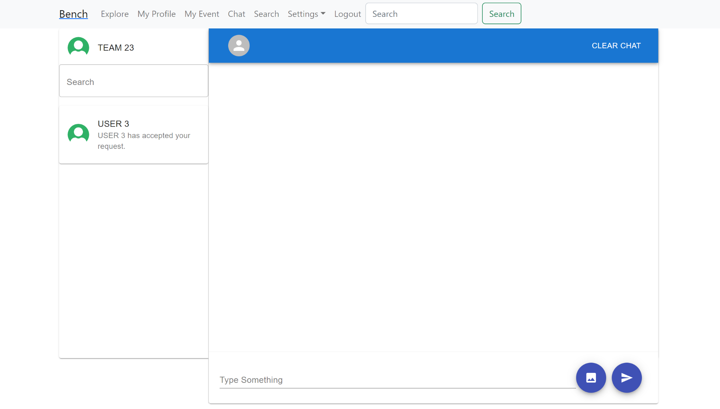

**Test 2**

1. Start the Bench application.
2. Click the button “Login” on the navigation bar.
3. Enter the email “team23project@gmail.com” into the text field labeled “Email address”.
4. Enter the password “12345678” into the field labeled “Password”.
5. Click the button “Login” below the field.
6. After the screen has loaded, click on the button “Chat” on the navigation bar.
7. There should be a list of panels for accepted chats on the left side of the Chat page.
8. Click on any of the chat panels.

**Expected Result:** There should appear a chat room that allows the current user to chat with the selected user on the right side of the Chat page.

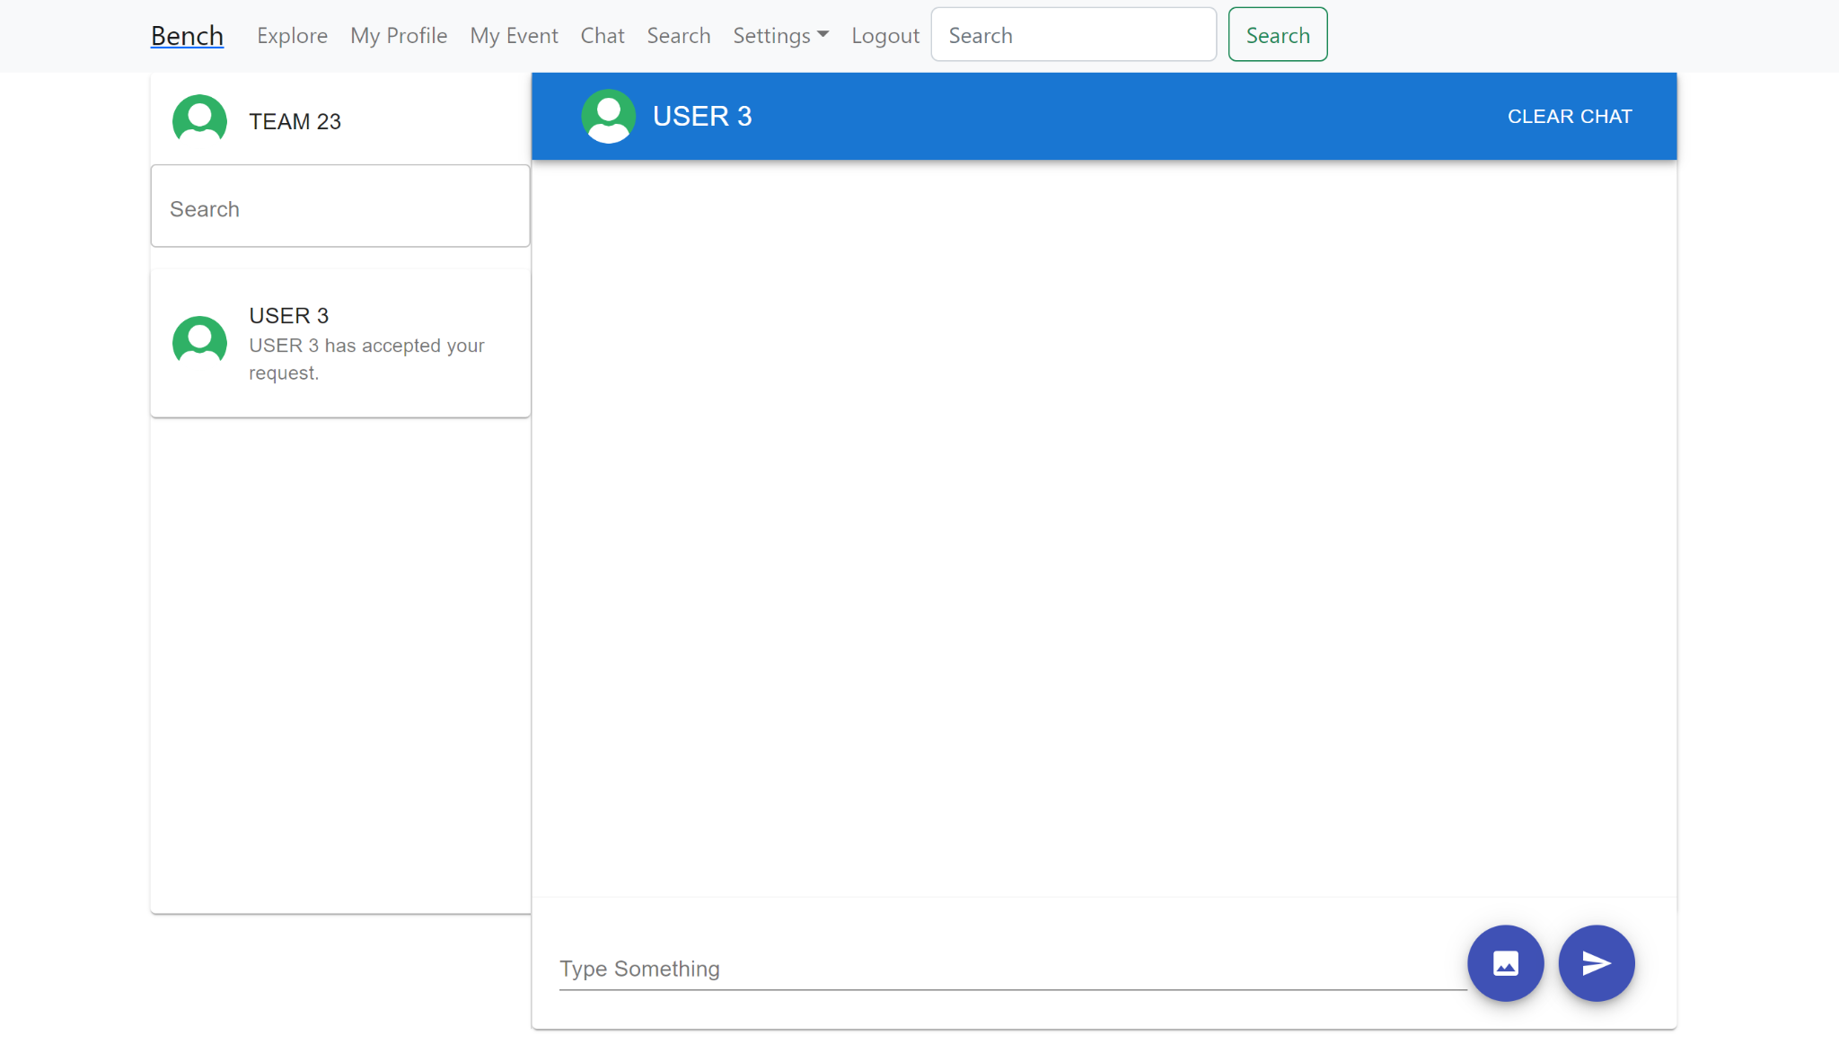

**Test 3**

1. Start the Bench application.
2. Click the button “Login” on the navigation bar.
3. Enter the email “team23project@gmail.com” into the text field labeled “Email address”.
4. Enter the password “12345678” into the field labeled “Password”.
5. Click the button “Login” below the field.
6. After the screen has loaded, click on the button “Chat” on the navigation bar.
7. There should be a list of panels for accepted chats on the left side of the Chat page.
8. Click on any of the chat panels.
9. There should appear a chat room that allows the current user to chat with the selected user on the right side of the Chat page.
10. Type a message in the text input field in the chat room.
11. Click the send button on the right of the text input field.
12. The specific message should appear in the chat history above the input field in the chat room.
13. Exist the Chat page by clicking on any button except “Chat” nor “Logout” on the navigation bar.
14. Return to the Chat page by clicking on the button “Chat” on the navigation bar.
15. Click on the chat panel of the user that you just sent a message to.

**Expected Result:** There should appear the chat room between the current user and the selected user on the right side of the Chat page, along with the chat history, including the message that you just sent to them.

